Q4 TRADING JOURNAL

01 September – 31 December 2024

Total Positions Taken: 6 Trades: 4 Total Percentage: 0.41% Wins: 2 Losses: 2 Break-even: 1

Symbol/Direction: EURNZD- LONG

Date Opened: 13/09/2024

Date Closed: 16/09/2024

Total Profit/Loss:

Note: ENTRY TYPE: Risk Entry (buy stop)

EMOTIONS I feel confident taking the trade as price has formed a a small bearish consolidation inside of a bear flag (two touch flag) observing PSE.

FORECAST OF THE POSITION: Price expected to at least reach and breach a value area.
Screenshots:

Before:

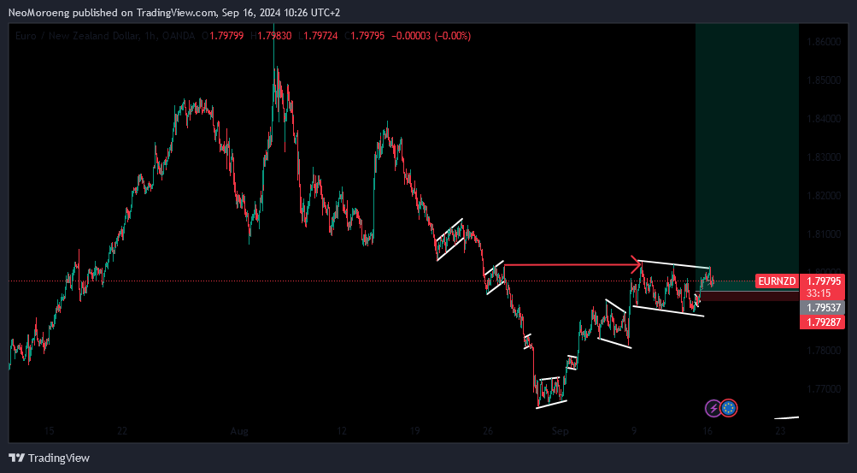

- taking position inside a bear flag.

After:

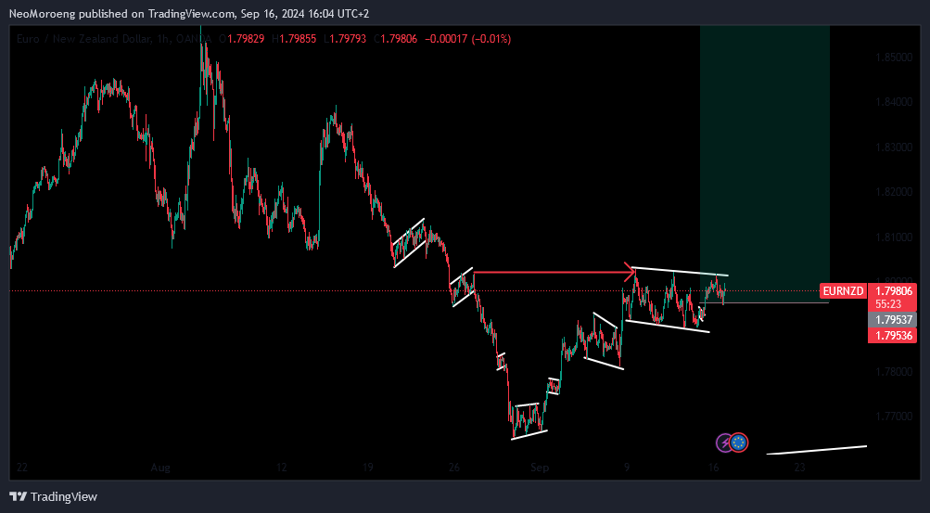

(Add the timeframes that helped influence your decision to open the position)

- (quick note about execution of position, example, the profit target at the bottom of the structure has been reached)

Trade Refinement Questions:

What was the biggest lesson you learned from executing and managing this position?

We could have waited for an insurance entry confirming the trade.

What could you do next time in a similar situation to maximize your profit potential?

Adhere to PSE for better execution

Be honest with yourself, was this trade congruent with your trading plan?

NO, it only followed structure and not all PSE values.

Would this be a trade that you execute again on a million dollar account? Yes or no? (the answer should be yes) NO

Symbol/Direction: AUDNZD- SHORT

Date Opened: 16/09/2024

Date Closed: 17/09/2024

Total Profit/Loss: 0

Note: ENTRY TYPE: Reduced Risk Entry (sell stop)

EMOTIONS I feel confident taking the trade as price has formed a two touch bear flag.

FORECAST OF THE POSITION: Price has retested and rejected of a larger three touch structure and is expected to reach a 90% of the beginning of the bear flag.
Screenshots:

Before:

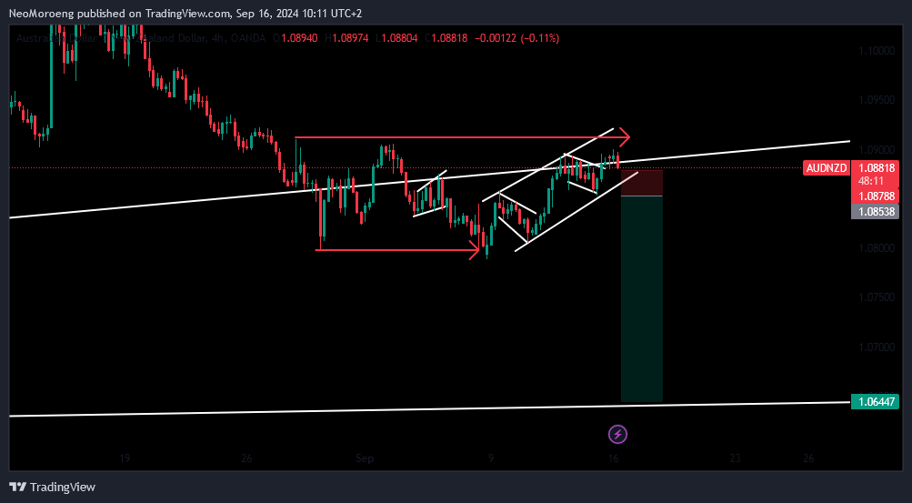

- taking position at a retest of a larger bear flag and a break of a smaller a bear flag.

After:

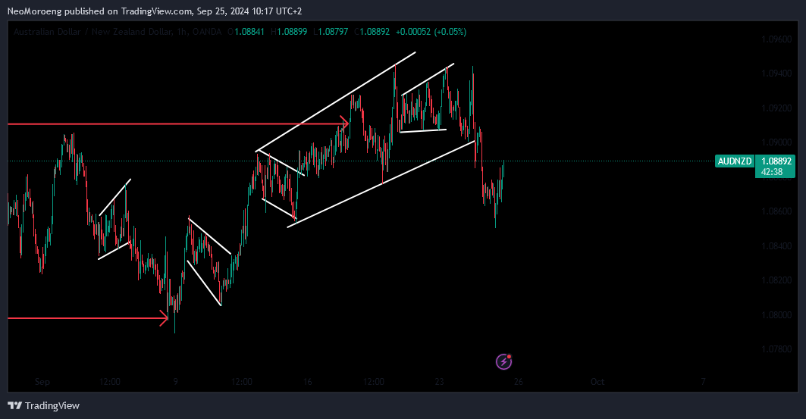

(Add the timeframes that helped influence your decision to open the position)

- Position was invalided to early and stop was too tight so position would have triggered SL

Trade Refinement Questions:

What was the biggest lesson you learned from executing and managing this position?

We could have waited for an insurance entry confirming the trade.

What could you do next time in a similar situation to maximize your profit potential?

Adhere to PSE for better execution

Be honest with yourself, was this trade congruent with your trading plan?

NO, it only followed structure and not all PSE values.

Would this be a trade that you execute again on a million dollar account? Yes or no? (the answer should be yes) NO

Symbol/Direction: EURAUD- SHORT

Date Opened: 16/09/2024

Date Closed: 20/09/2024

Total Profit/Loss: 0.28

Note: ENTRY TYPE: Reduced Risk Entry (sell stop)

EMOTIONS I feel confident taking the trade as price has formed a two touch bear flag.

FORECAST OF THE POSITION: Price has retested Price has already breached a value area and is expected to commit to a long term short in the day time frame.
Screenshots:

Before:

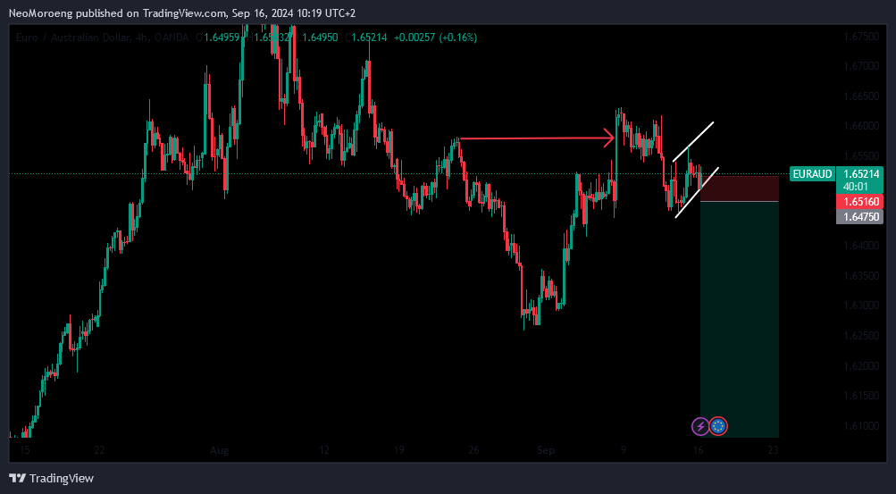

- taking position at a break of a smaller bear flag.

After:

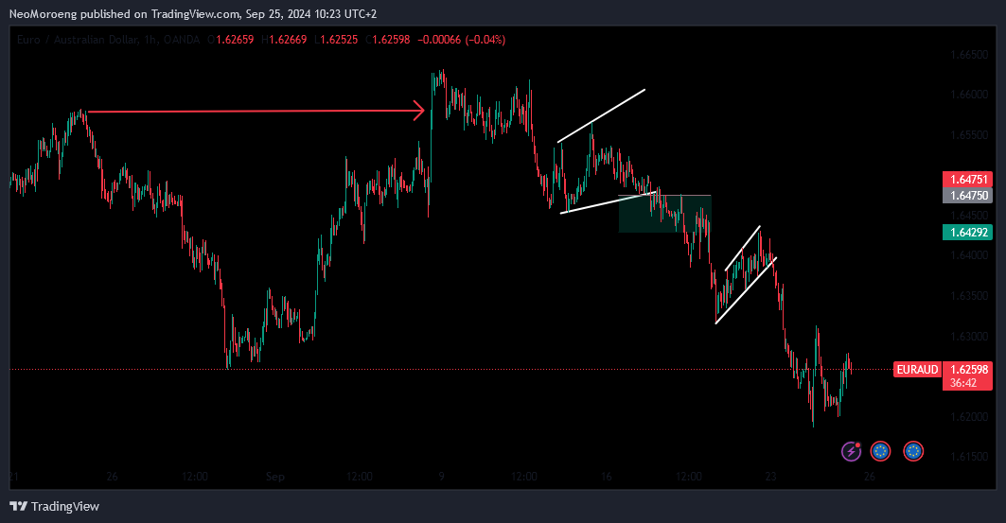

(Add the timeframes that helped influence your decision to open the position)

- (quick note about execution of position, example, the profit target at the bottom of the structure has been reached)

Trade Refinement Questions:

What was the biggest lesson you learned from executing and managing this position?

We could have waited for an insurance entry confirming the trade.

What could you do next time in a similar situation to maximize your profit potential?

Adhere to PSE for better execution

Be honest with yourself, was this trade congruent with your trading plan?

NO, it only followed structure and not all PSE values.

Would this be a trade that you execute again on a million dollar account? Yes or no? (the answer should be yes) NO

Symbol/Direction: GBPNZD- SHORT

Date Opened: 24/09/2024

Date Closed:

Total Profit/Loss: 0.3

Note: ENTRY TYPE: Risk Entry (buy stop)

EMOTIONS I feel confident taking the trade as price has formed tight bear flag inside an expanding wedge.

FORECAST OF THE POSITION: Price has rejected on a value area on H4 and has formed a three touch structure, I’m looking for prIce to reach 90% of the beginning of the bearish H4 structure
Screenshots:

Before:
H4

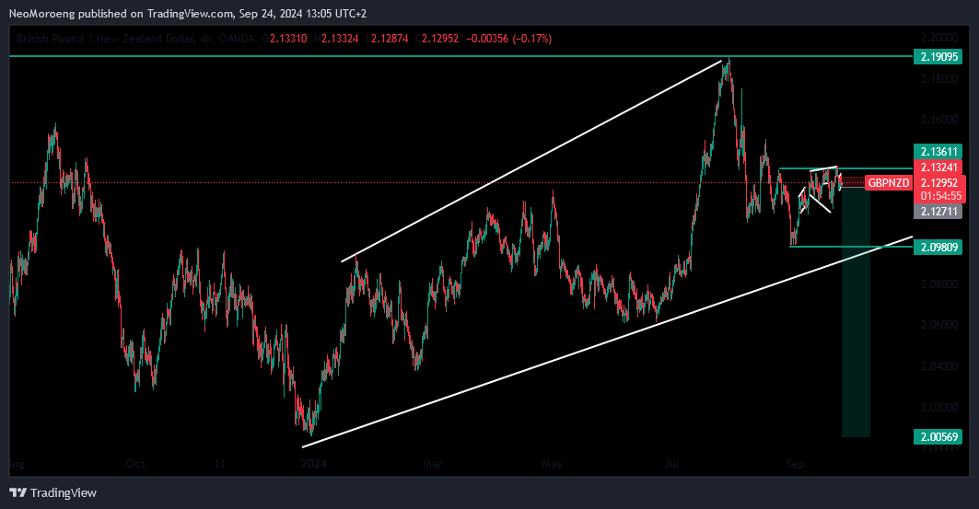

H1

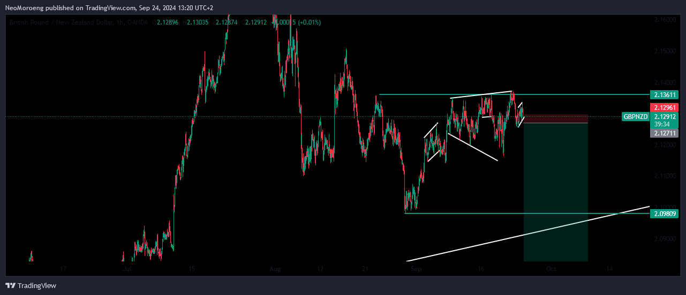
After:

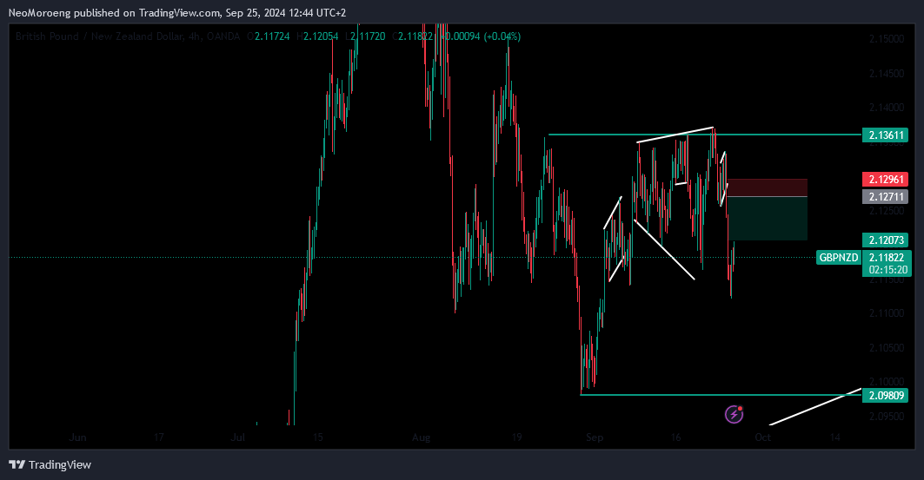

(Add the timeframes that helped influence your decision to open the position)

- (quick note about execution of position, example, the profit target at the bottom of the structure has been reached)

Trade Refinement Questions:

What was the biggest lesson you learned from executing and managing this position?

We could have waited for an insurance entry confirming the trade.

What could you do next time in a similar situation to maximize your profit potential?

Adhere to PSE for better execution

Be honest with yourself, was this trade congruent with your trading plan?

NO, it only followed structure and not all PSE values.

Would this be a trade that you execute again on a million dollar account? Yes or no? (the answer should be yes) NO

Symbol/Direction: EURCAD- SHORT

Date Opened: 24/09/2024

Date Closed: 25/09/2024

Total Profit/Loss: -0.17

Note: ENTRY TYPE: Risk Entry (sell stop)

EMOTIONS I feel confident taking the trade as price has formed a bear flag inside an expanding wedge.

FORECAST OF THE POSITION: price as formed a near miss off an inflection area so Im looking for breach of the beginning of the wedge structure as possible area for price retracing because of the near miss.

Screenshots:

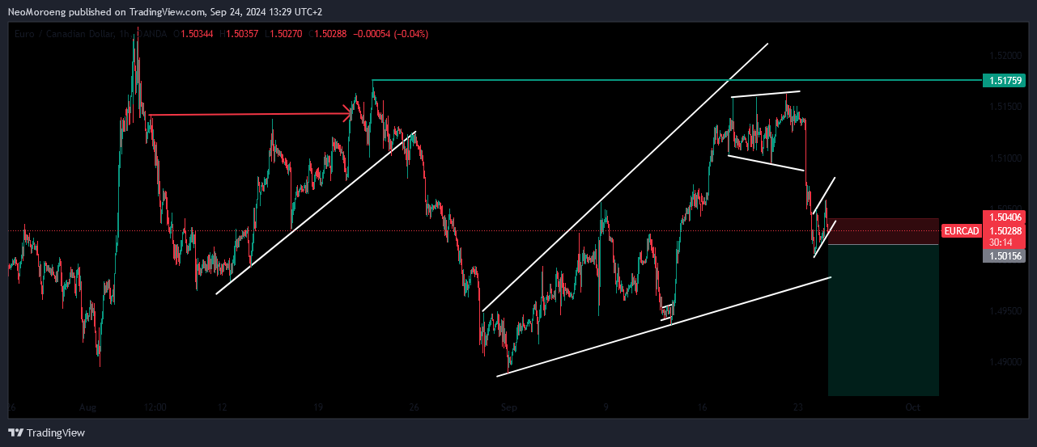

Before:

- taking position at a break of a smaller bear flag.

After:

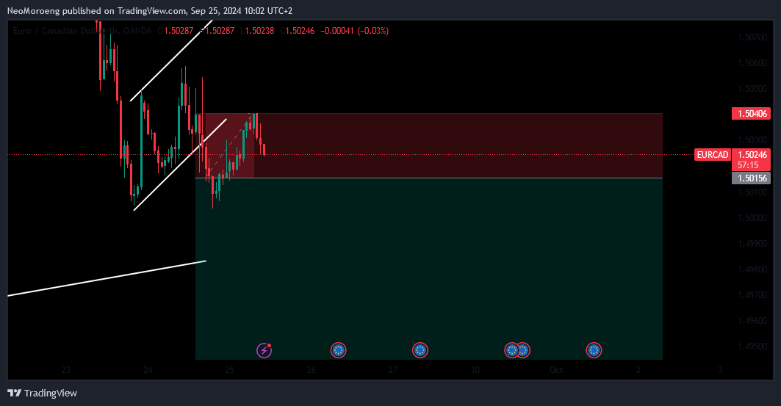

(Add the timeframes that helped influence your decision to open the position)

- SL was to tight at 0.17 instead of 0.25, I set it at 0.17 due to calculating a much high SL in terms of P&L

Trade Refinement Questions:

What was the biggest lesson you learned from executing and managing this position?

We could have waited for an insurance entry confirming the trade.

What could you do next time in a similar situation to maximize your profit potential?

Adhere to PSE for better execution

Be honest with yourself, was this trade congruent with your trading plan?

NO, it only followed structure and not all PSE values.

Would this be a trade that you execute again on a million dollar account? Yes or no? (the answer should be yes) NO

Symbol/Direction: USDCAD- SHORT

Date Opened: 25/09/2024

Date Closed:

Total Profit/Loss:

Note: ENTRY TYPE: RE (sell stop)

EMOTIONS I feel confident taking the trade as price has formed a tight bear flag under an inflection area.

FORECAST OF THE POSITION: price as formed a near a tight bear flag under an inflection area and Im expecting it to at least breach 90% of the beginning of the bullish trend which marks a value area, which Is visible on H4.

Screenshots:

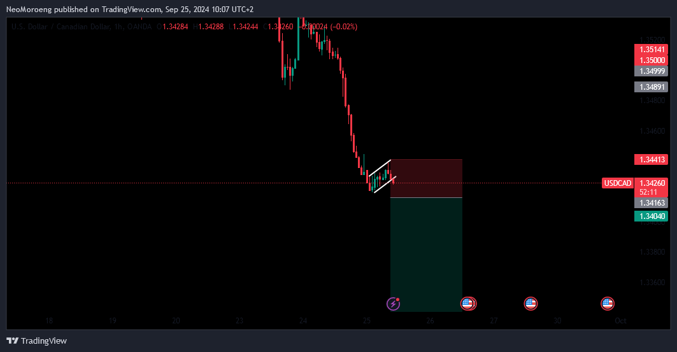

Before:

- taking position at a break of a smaller bear flag.

After:

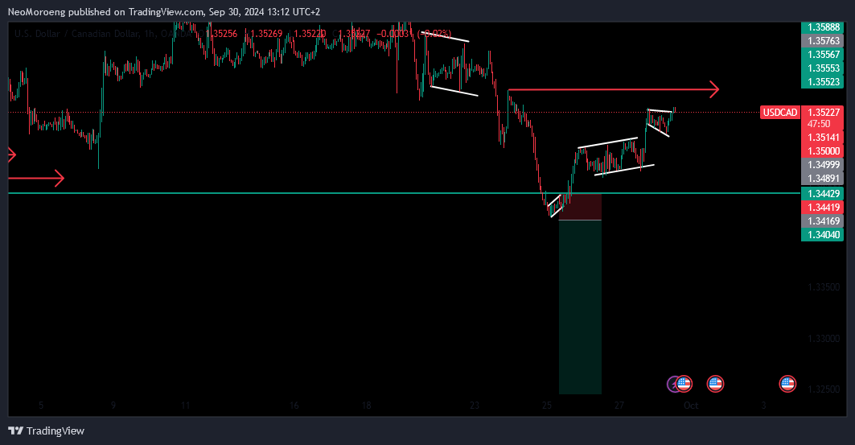

(Add the timeframes that helped influence your decision to open the position)

- position was invalid

Trade Refinement Questions:

What was the biggest lesson you learned from executing and managing this position?

We could have waited for an insurance entry confirming the trade.

What could you do next time in a similar situation to maximize your profit potential?

Adhere to PSE for better execution

Be honest with yourself, was this trade congruent with your trading plan?

NO, it only followed structure and not all PSE values.

Would this be a trade that you execute again on a million dollar account? Yes or no? (the answer should be yes) NO

Symbol/Direction: AUDNZD- LONG

Date Opened: 30/09/2024

Date Closed:

Total Profit/Loss:

Note: ENTRY TYPE: RRE (buy stop)

EMOTIONS I feel confident taking the trade as price has formed a three touch bull flag under visible in both H1 and H4

FORECAST OF THE POSITION: price as formed a near three touch bull flag and I’m expecting price to reach the inflection area as tp, RR is1:3.

Screenshots:

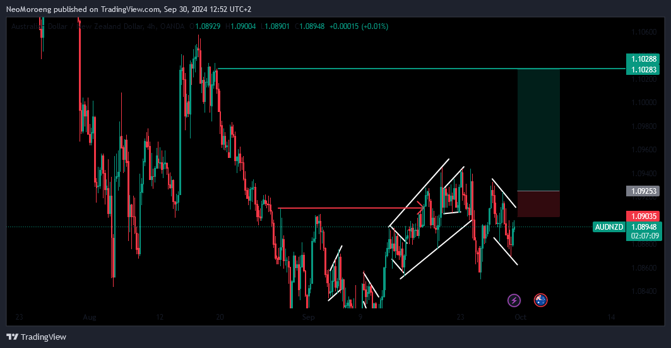

Before:

- taking position at a break of a smaller bear flag.

After:

(Add the timeframes that helped influence your decision to open the position)

- position was invalid

Trade Refinement Questions:

What was the biggest lesson you learned from executing and managing this position?

We could have waited for an insurance entry confirming the trade.

What could you do next time in a similar situation to maximize your profit potential?

Adhere to PSE for better execution

Be honest with yourself, was this trade congruent with your trading plan?

NO, it only followed structure and not all PSE values.

Would this be a trade that you execute again on a million dollar account? Yes or no? (the answer should be yes) NO

Symbol/Direction: NZDJPY- SHORT

Date Opened: 30/09/2024

Date Closed:

Total Profit/Loss:

Note: ENTRY TYPE: RRE (sell stop)

EMOTIONS I feel confident taking the trade as price has formed a bearish continuation flag after rejecting of an inflection area.

FORECAST OF THE POSITION: price is expected to sell to 90% of the beginning of the previous momentum.

Screenshots:

Before:

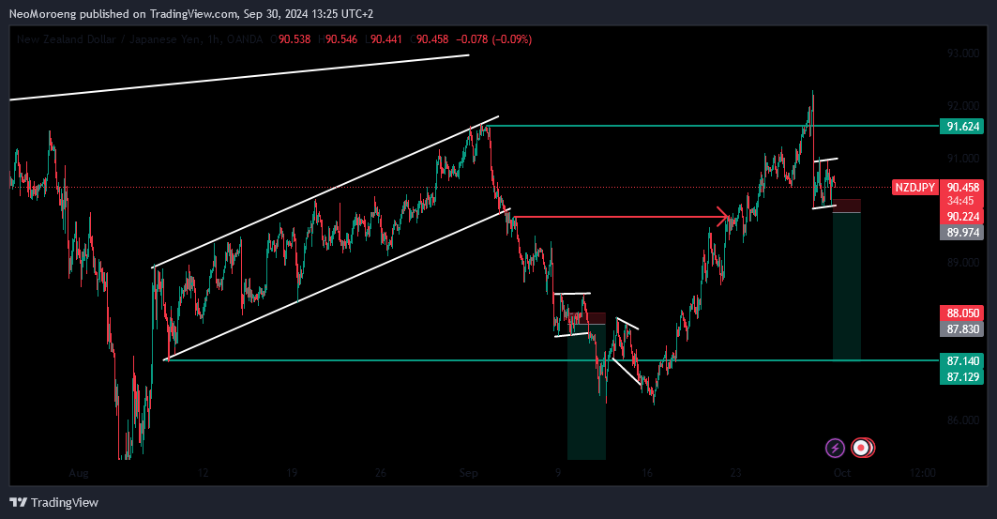

- taking position at a break of a smaller bear flag.

After:

(Add the timeframes that helped influence your decision to open the position)

- position was invalid

Trade Refinement Questions:

What was the biggest lesson you learned from executing and managing this position?

We could have waited for an insurance entry confirming the trade.

What could you do next time in a similar situation to maximize your profit potential?

Adhere to PSE for better execution

Be honest with yourself, was this trade congruent with your trading plan?

NO, it only followed structure and not all PSE values.

Would this be a trade that you execute again on a million dollar account? Yes or no? (the answer should be yes) NO

